KATHMANDU UNIVERSITY
SCHOOL OF ENGINEERING
DEPARTMENT OF GEOMATICS ENGINEERING



A FIELD REPORT ON
LEVELLING, TRAVERSING, TACHEOMETRY

Submitted by:
Deepak Raj Joshi (035272-23)
Jenish Kafle (035277-23)
Nischal Katuwal (035280-23)
Sudan Khanal (035281-23)
Pratik Khatiwada (035283-23)

Department of Geomatics Engineering
School of Engineering
Kathmandu University
Dhulikhel, Kavre
14 March 2025

ACKNOWLEDGEMENT

We would like to extend our sincere gratitude to the Department of Geomatics Engineering for their invaluable support and guidance throughout the course of this project. Their contributions have been pivotal to the successful completion of our semester project.
Additionally, we wish to express our heartfelt appreciation to all the faculty members and staff who participated in this project. Their generosity in sharing their expertise and knowledge has been crucial in bringing this report to fruition. Their dedication and commitment to excellence have been truly inspiring, and we feel privileged to have collaborated with such an exceptional team.
We are profoundly grateful for the opportunity to work with the Department of Geomatics Engineering, and for the unwavering support and guidance provided by all the involved faculty and staff. We hope this report will be beneficial to future researchers and practitioners in the field, and we remain dedicated to advancing the knowledge and understanding in this significant area of study.
Thank you.

ABSTRACT

This project report outlines the use of various surveying techniques within the area of Kathmandu University. The project involved the use of several surveying techniques including levelling, theodolite traverse and tachometry. The report begins by describing the objectives of the project and the specific challenges faced in the area. The techniques used were chosen based on the specific requirements of the project and the terrain.
The levelling technique was used to determine the height of different points on the terrain.
While the theodolite traverse technique was used to measure the angles and distances between points in order to establish their positions.
The tachometry technique was used to measure the vertical and horizontal distances of points, as well as to determine the elevation of different points on the terrain to prepare topographic map of the area.
The results obtained from these techniques were then used to create detailed topographical maps and different graph plots of elevation of the area.
Overall, the use of these surveying techniques enabled the accurate determination of the positions and elevations of different points on the terrain in the Kathmandu University area. The results obtained will be useful for future projects in the area and will contribute to the development of the field of land surveying.
Project title: Levelling, Traversing and Tachometry
Location: Kathmandu University
Surveyed by: Group 4

Batch 2023, GE 2nd year First Semester

LEVELLING

Contents
List of Tables ii
List of Figures iii
List of Abbreviations iv
- Introduction 1
  - Background 1
  - Objective 3
  - Scope 4
  - Technical terms used in leveling 4
- Methodology 5
  - Instruments used 5
  - Study Area 6
  - Specifications 7
  - Methodology 7
    - Planning and reconnaissance 8
    - Monumentation 8
    - Test of the instrument 8
    - Field Work 8
    - Error adjustment & computation 10
  - Field Procedure refinement and their reasons 11
  - Sources of error 11
    - Personal error 11
    - Instrumental Error 11
    - Natural Error 11
- Results and discussions 12
- Conclusion 12
References 12
Annexes 12

List of Tables

Table 1: Specifications 7
Table 2: Procedure refinement and reasons 11
Table 4: Output of leveling work 12

List of Figures
Figure 1: Principle of levelling 1
Figure 2: Spirit Leveling 2
Figure 3: Study Area 6
Figure 4: Methodological Diagram 7

List of Abbreviations

B | Back staff
BM | Benchmark
BS | Back sight
F | Fore staff
FS | Foresight
GPS | Global Positioning System
ΔH | Height Difference
HI | Height of Instrument
IS | Intermediate Sight
PBM | Permanent Benchmark
RL | Reduced Level
SI | Staff Intercepts
TBM | Temporary Benchmark

  - Background

Introduction

Geomatics Engineering is primarily concerned with the acquisition of spatial data and the creation of control networks required for this purpose. Control surveys are an essential tool and skill for surveyors, providing the horizontal and vertical control points necessary before beginning any survey work. These control points are established through methods such as traversing, triangulation, and trilateration for horizontal control, and leveling for vertical control.
Leveling is a method of surveying used for determination of the difference of elevation or
height of various points on the surface of the earth. The elevation of a point is its vertical distance above or below a reference level, known as a datum. Leveling involves vertical plane measurements and is critical for engineering projects like railways, highways, canals, dams, and water supply and sanitation systems. The success of these projects relies on accurately determining the elevations of various points along the project alignments.

Principle of levelling:

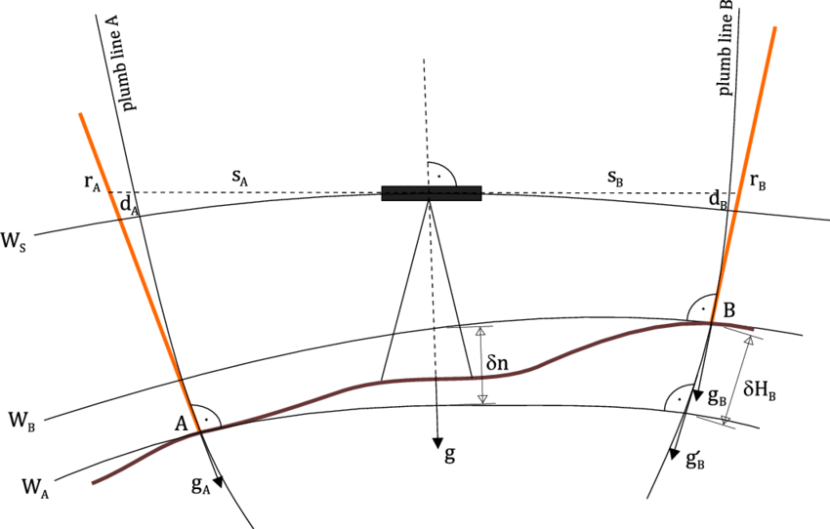
Fig : principle of levelling
The line of sight is provided with level instrument and a graduated leveling staff.
In above figure, the height difference between A and B is required, C is the position of level instrument. A'B' is the line representing the line of sight, which is perpendicular to the plumb
line.rA and rB be the reading on vertically held staff at position Aand B
Now,
ΔHAB = rB - rA = (A) - ΔHA - ( B) + ΔHB………. Eq(1)
When, ΔHA = ΔHB (spherical approximation, equal distance to A and B)
Therefore, Equation 1 becomes
ΔHAB = rB - rA
Then, ΔHAB is the difference in elevation for height difference between A & B station on the surface of the earth.
Vertical control points: Vertical control points are fixed reference points with known elevations relative to a common datum. They serve as benchmarks for determining height differences in surveying and construction projects. These points ensure accuracy in elevation measurements for infrastructure development, such as roads, bridges, and drainage systems. Vertical control is typically established using leveling techniques like differential leveling, precise leveling, and trigonometric leveling. Vertical controls are also known as benchmarks; the elevations or height of the benchmarks is established about the datum, relatively called Mean sea level. There are many methods to find the height of vertical controls. Some of them are:
- Spirit Leveling
- Trigonometric leveling
- Barometric leveling
- Hypsometric leveling
- Hydrostatic leveling
- GPS leveling
Spirit Leveling: Spirit leveling is a precise method of determining elevation differences between points using a leveling instrument and a leveling staff. It relies on the principle of establishing a horizontal line of sight and measuring vertical distances relative to it. A spirit level (a bubble level) within the instrument ensures that the line of sight remains perfectly horizontal.
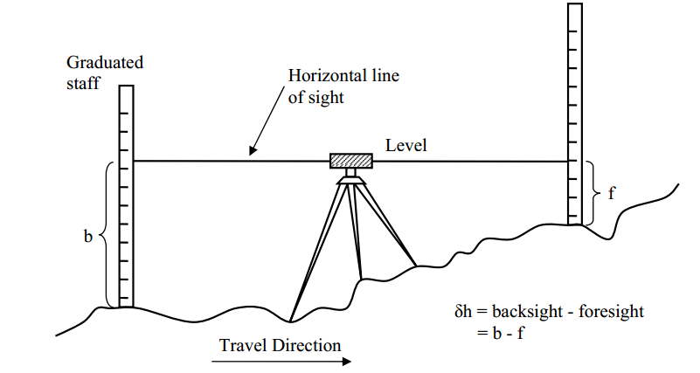
Figure 2: Spirit Leveling
Leveling is essential in surveying for the following purposes:
- To find the relative heights of points.
- To create accurate land surface maps.
- To ensure level foundations and proper grading.
- To provide data for engineering designs.
- To track elevation shifts.
- To create elevation reference points.
- To determine the undulation of the of the earth surface for topographical mapping.

Objectives

  - To determine the relative elevations of different points on the Earth's surface.
  - To establish a series of benchmarks with known elevations for future surveying work.
  - To provide data for the creation of topographic maps and profiles.
  - To provide elevation data necessary for the design and construction of engineering projects.
  - Establish benchmarks and determine their elevations above mean sea level (MSL)
  - Learn levelling concepts, procedures, and applications, including cross section leveling.
  - Accurately record readings and understand checks and errors in leveling

Scope
We have established the RL of 6 TBMs and 2 PBMs on the area by the method of levelling. Field survey for leveling was completed in five days and Error adjustment & computation in a day. The result shows that the Benchmarks have been established with the accuracy required for the fourth-order.

Technical terms used in leveling
Level surface: Any surface parallel to the mean spheroid surface of the earth is called level surface. It is normal to the vertical line at every point on it.

Level line: The level line is a line on a level surface.

Horizontal plane: A surface tangential to level surface at a given point is called a Horizontal plane.

Vertical line: The line connecting the point to the centre of the earth is known as Vertical line.

Vertical Plane: The plane containing the vertical line at a place is called the vertical plane.

Datum: It is the level or the surface which is taken as a reference surface for the determination of the elevation of various points.

Mean Sea Level (MSL): MSL is the average height of the sea for all stages of the tides.

Benchmarks: It is a point of known elevation above or below a datum.

Permanent Benchmarks: The benchmarks which are established with reference to National reference point (survey department of any country) are known as Permanent benchmarks.

Line of collimation: It is an imaginary line passing through the intersection of the cross hairs at the diaphragm and optical centre of the objective lens. It is also known as line of sight.

Instrument Station: The point where the instrument is set up for observation is called the instrument station.

Station: The station is the point where the staff is held for taking observation from a leveling instrument.
Backsight: It is the reading taken on a staff held at a point of known elevation or at the point whose elevation has already been determined.

Foresight: It is the last sight reading taken from any instrument position before shifting the instrument.

Intermediate sight: All readings taken between backsight and foresight are intermediate.

Turning point: For leveling over a long distance, the instrument has to be set up a number of times. A turning point is the point selected on the route before shifting the instrument where both BS and FS . The turning point is also called a change point.

Elevation: The height of a point above or below a fixed reference point is elevation.

Single tertiary leveling: Tertiary leveling carried out by taking only one set of reading at each staff is called single tertiary leveling. It does not check to provide on rise and fall independently.

Double tertiary: Tertiary leveling carried out by taking two or more than two sets of reading in each staff is called Double tertiary leveling. It provides a check on rise and fall.

Rise-Fall method: The method of determining elevation between two consecutive points by comparing each point immediately preceding is known as the rise fall method in leveling.

Height of collimation method: It is the method that consists of finding the elevation of the plane of collimation (H.I.) for every set up of the instrument and then obtaining the reduced level of point about the respective plane of collimation.

Arithmetic check in leveling: This refers to the computation check for backsight (B.S.) and foresight (F.S.), rise and fall & first reduced level and Last Reduced level in any leveling work. Arithmetic checks if OK means that the computation of the field book is correct.

Arithmetic check: ∑ B.S. - ∑ F.S. = ∑ Rise - ∑ fall = Last R.L –First R.L

  - Instruments used

Methodology

The following instruments were used at field for leveling:
- Automatic level with tripod -1
- Staff - 2

- Measuring tape – 1

Study Area

The study area comprises a region of Dhulikhel municipality in Kavrepalanchowk district. The leveling was run along the KU road from a PBM near KU-Gate to near a Boys hostel.
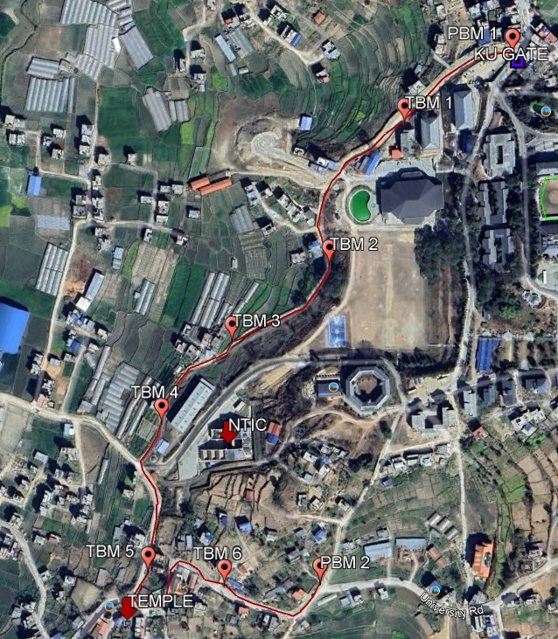

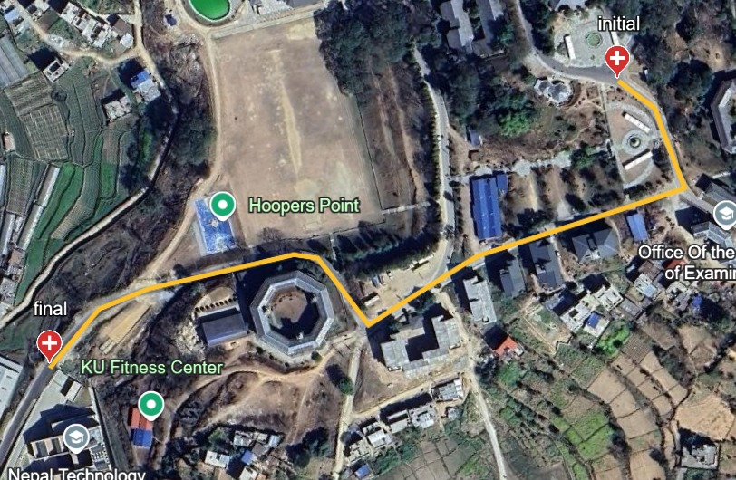

Figure 3: Study Area

Specifications

Table 1: Specifications

Particulars | Specification
Type of levelling | Differential levelling
Order of work | 4th order
Purpose | To determine the elevation of benchmarks  Above MSL.
Instrument | Auto levelling
Unit of measurement | Meters
No. of setups between BM | Even
Maximum sight distance | 15m
Linear measurement direction | Two- way, double measurement
Working time | Whole day
Tolerance for back and fore leveling | ±12.5√K mm
Staff reading | Above 0.3m- Below 2.7m
Adjustment method | Bowditch Rule

Methodology
The leveling was carried out in following phases a shown in the figure below:
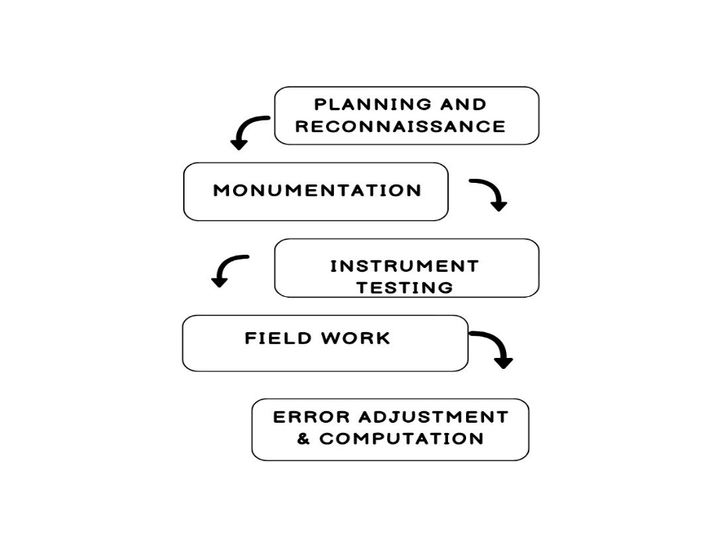
Figure 4: Methodological Diagram

Planning and reconnaissance
In this phase, the area was selected for leveling. The area was visited and studied the feasibility to carry out a leveling procedure. As the area was near the locality, the leveling route was defined by a field visit. Tentative locations for Bench Marks were selected at the stable ground in leveling route. In this phase, the locations of temporary and permanent benchmarks were selected.

Monumentation
Selected bench marks were numbered using fourth order numbering. Following BM number were used for PBMs and TBMs.
PBM-1: 400-001
PBM-2: 400-002 TBM-1: 400-001/1 TBM-2: 400-001/2
TBM-3: 400-001/3
TBM-4: 400-001/4 TBM-5: 400-001/5
TBM-6: 400-001/6

BMs were monumented by marking on the ground. In total, two PBMs and six TBMs were monumented.

Test of the instrument
It is necessary to check the instrument’s condition before starting any survey. So the collimation error in the level instrument was tested by two peg test methods. Firstly, two graduation staff were placed at a distance of 20m on a horizontal surface. Then the level instrument was set between those staffs, i.e. 10m from each staff, the BS and FS reading were taken, and the rise and fall between the staffs was calculated.
Secondly, the instrument was set near the staff, i.e. 5m. BS and FS reading was taken of graduation staff, and rise and fall were calculated. Both rise and fall values were compared, and the collimation error was found. The collimation error was laid in the tolerance; hence the instrument was made ready for leveling.

Field Work
The following procedures were done during leveling and Booking was also done at the same time in the field which is described below:

- Initially, fieldwork was started from PBM 400-00l locate at KU-Gate up to PBM2 infront of the Kathmandu university school of law and near a KU hostel along the leveling route with six TBMs.
- Before taking readings, the level instrument was leveled accurately.
- Graduated levelling staff were placed at stable ground except on B during levelling work.
- To avoid the collimation error in the level instrument, the backsight and foresight distance was approximately balanced.
- The staffs were placed vertically during leveling.
- To avoid the curvature and refraction error in leveling, the maximum foresight and backsight distance was 30m.
- The instrument was shifted to another station if the reading was within the tolerance.
- When the readings of three wires were averaged, the reading was accepted if the average value was equal to the middle wire reading. If the average value was not equal to the middle reading, reading was repeated.

Recording/calculation

- Loose-leaf leveling sheets were used to record details of the area, work, date, foresight and back sight-reading, observer, and recorder.
- The first observation value (on the known point) was written in the backsight column, and sufficient details in the remark column were identified.
- The foresight reading after the first observation was recorded in the foresight column.
- The backsight and foresight distance was computed by the following formula, Distance = (t-b) * 100 where, t= top reading and b= bottom reading
- And the calculated distance was written in the distance column.
- Rise/ fall was computed by subtracting foresight with backsight, and the calculated value was written in the Rise/ fall column.
- The Reduced level of each station was computed by adding the Rise or fall with the previous reduced level of that line, and the calculated value was recorded in the RL column.
- The above procedure was repeated at each setup of the instrument.
- And elevation was found from the use of the height of collimation.

Error adjustment & computation
Arithmetic check:
∑ B.S. – ∑ F. S. = ∑Rise – ∑Fall = last R. L. – first R.L should be equal if not then there exists the computation error.
When the arithmetic check was completed the section was checked by comparing Backward and forward leveling. Forward and backward should be in tolerance defined by the horizontal distance in section check. The tolerance was: 12.5√K mm .Where, K = Distance in Km (calculated from mean of forward and backward leveling) in Km.
If the sectional check was out of tolerance, the Section was repeated else it was adjusted by distributing equal error in each direction
Following Formula was used to adjust error:
𝐶𝑢𝑚𝑢𝑙𝑎𝑡𝑖𝑣𝑒 𝐷𝑖𝑠𝑡𝑎𝑛𝑐𝑒

𝑇𝑜𝑡𝑎𝑙 𝐷𝑖𝑠𝑡𝑎𝑛𝑐𝑒
∗ 𝑇𝑜𝑡𝑎𝑙 𝐸𝑟𝑟𝑜𝑟

2.5 Field Procedure refinement and their reasons

Table 2: Procedure refinement and reasons

S.N | Procedure Refinement | Reasons
1. | Backsight and foresight distance  Balanced. | To eliminate the collimation error in level  Instrument.
4. | Staff readings taken not less than 0.3m  and more than 2.7m | To reduce shimmering effect and to avoid wind effect.
5. | Even set up from BM to BM. | To eliminate the zero error of staff

2.6 Sources of error
Following three are the major sources of error in leveling.

2.6.1 Personal error
Error caused due to personal carelessness of personal cause is called Personal error. The significant personal errors during leveling were:
- Mistake in holding the staffs
- Error in sighting
- Error due to mistakes in recording and computation

2.6.2 Instrumental Error
Leveling operation consists of holding the Leveling staff on a point while the level makes a staff reading. So, instrumental errors comes from staff and leve.The primary instrumental errors during leveling were:
- Error due to imperfect adjustment (collimation error)
- Error due to sluggish bubble
- Error due to movement of the objective side
- Error due to rod not of standard length (Zero Error, Graduation error)

2.6.3 Natural Error
Error caused due to the natural component is known as Natural error. The significant natural error during leveling was:
- The curvature of the earth
- Variation in temperature
- Settlement in tripod
- Wind Vibration
- Refraction

Results and discussions
The height of vertical points was computed by using mean height difference of two sections backward and forward leveling of same line. Following table shows the output of leveling work:

From | To | Compu  Reduced level above MSL
PBM1 |  | 1490.500
PBM1 | TBM1 | 1473.450
TBM1 | TBM2 | 1462.813
TBM2 | TBM3 | 1458.487
TBM3 | TBM4 | 1456.915
TBM4 | TBM5 | 1460.116
TBM5 | TBM6 | 1468.900
TBM6 | PBM2 | 1467.219
Table 3: Output of LevelingWork
The Height of TBM1 was 1473.450m, the height of TBM2 was 1462.813m ,the height of TBM3 was 1458.487m ,the height of TBM4 was 1456.915m ,the height of TBM5 was 1460.116m,the height of TBM6 was 1468.900m and the height of PBM2 was 1467.219 . This was computed by a leveling operation. We can identify that The PBM2 was at a lower height than PBM1,TBM1 was at greater height than other temporary Benchmarks and TBM3 is at lower height than other temporary bench mark.

4 Conclusion

The leveling work spanned five days, during which we calculated the elevations of the benchmarks and plotted the nature of the ground surface on a graph using differential leveling. The attached graph illustrates our findings. Over the course of these five days, we gained substantial practical knowledge. This project also fostered teamwork and leadership skills.

References
Punmia, B.C, and Ashok Kumar Jain. 2005. “Surveying, Vol.1.” I: 195.

Annexes

Here are some glimpse of Photo
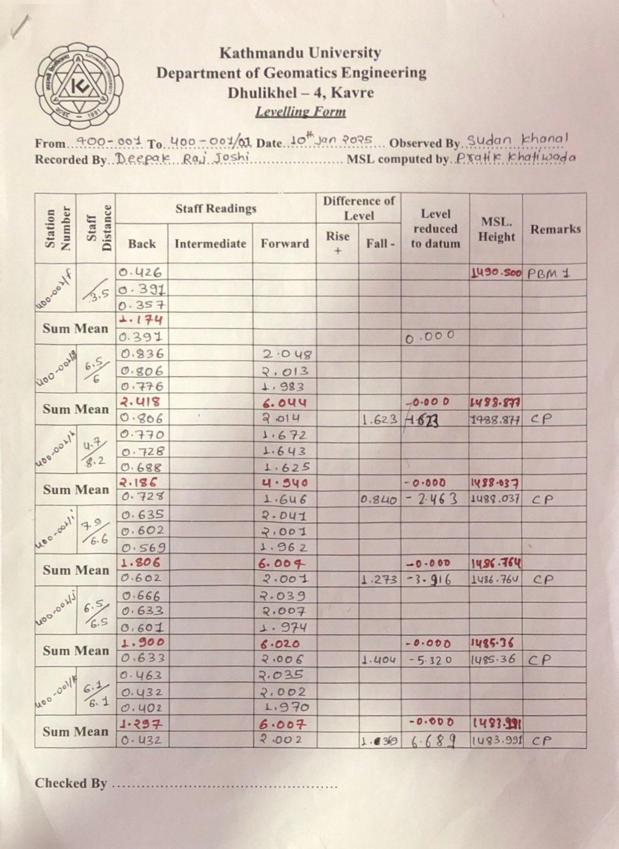

Annex – I: Field Book of levelling

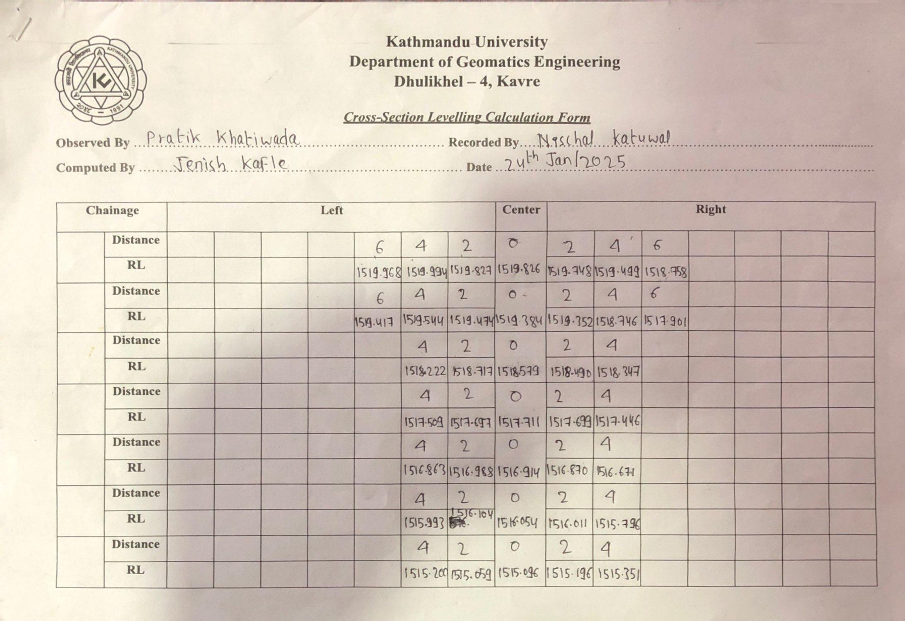

Annex – II: Field Book of cross section levelling

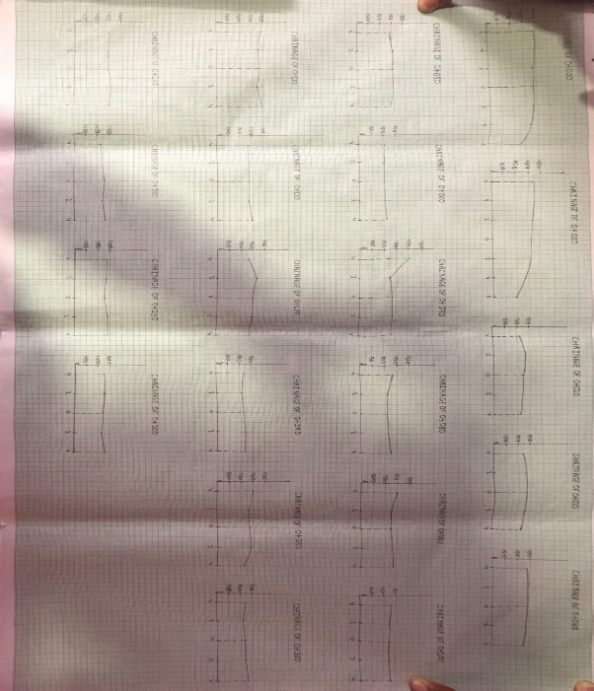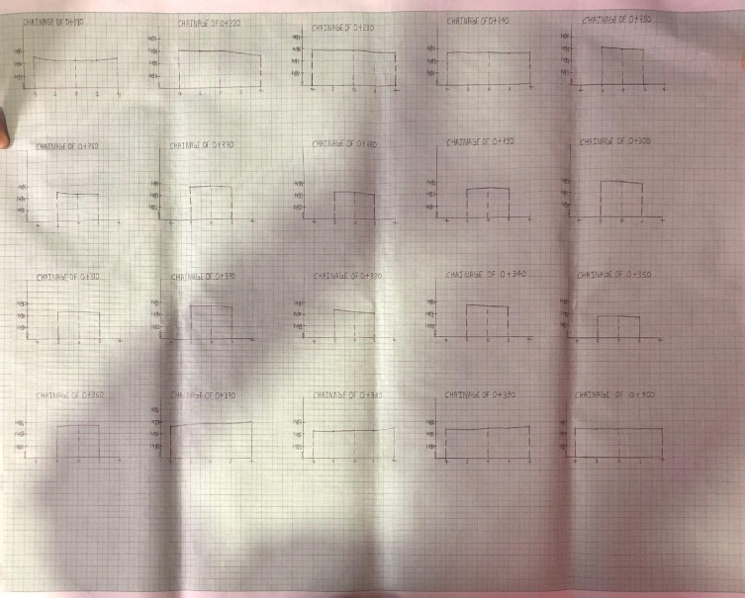

Annex- III : Graphs of Cross Sectional Levelling

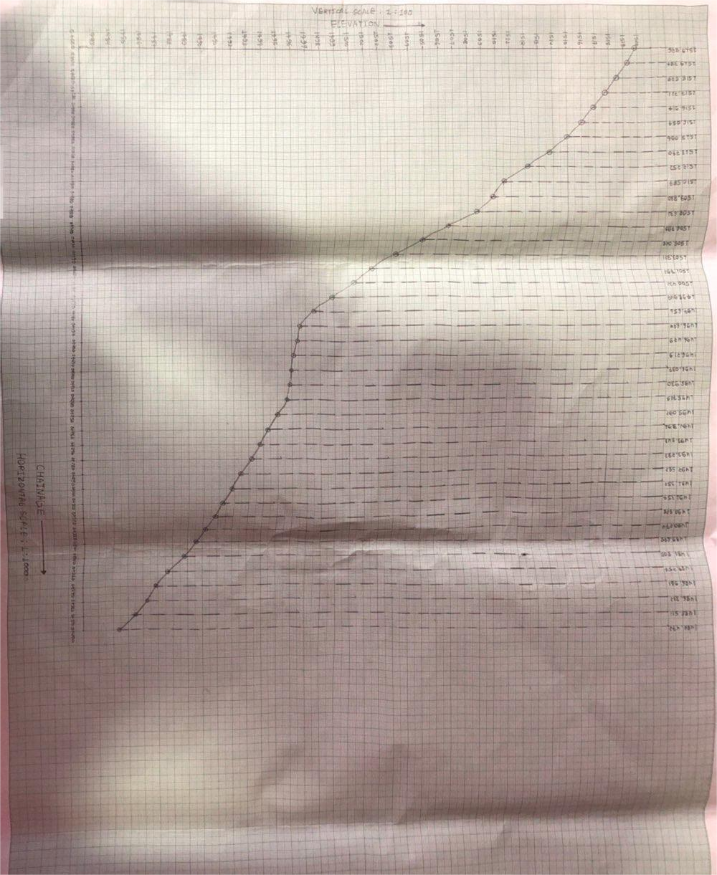

Annex- IV : Graphs of Profile Levelling

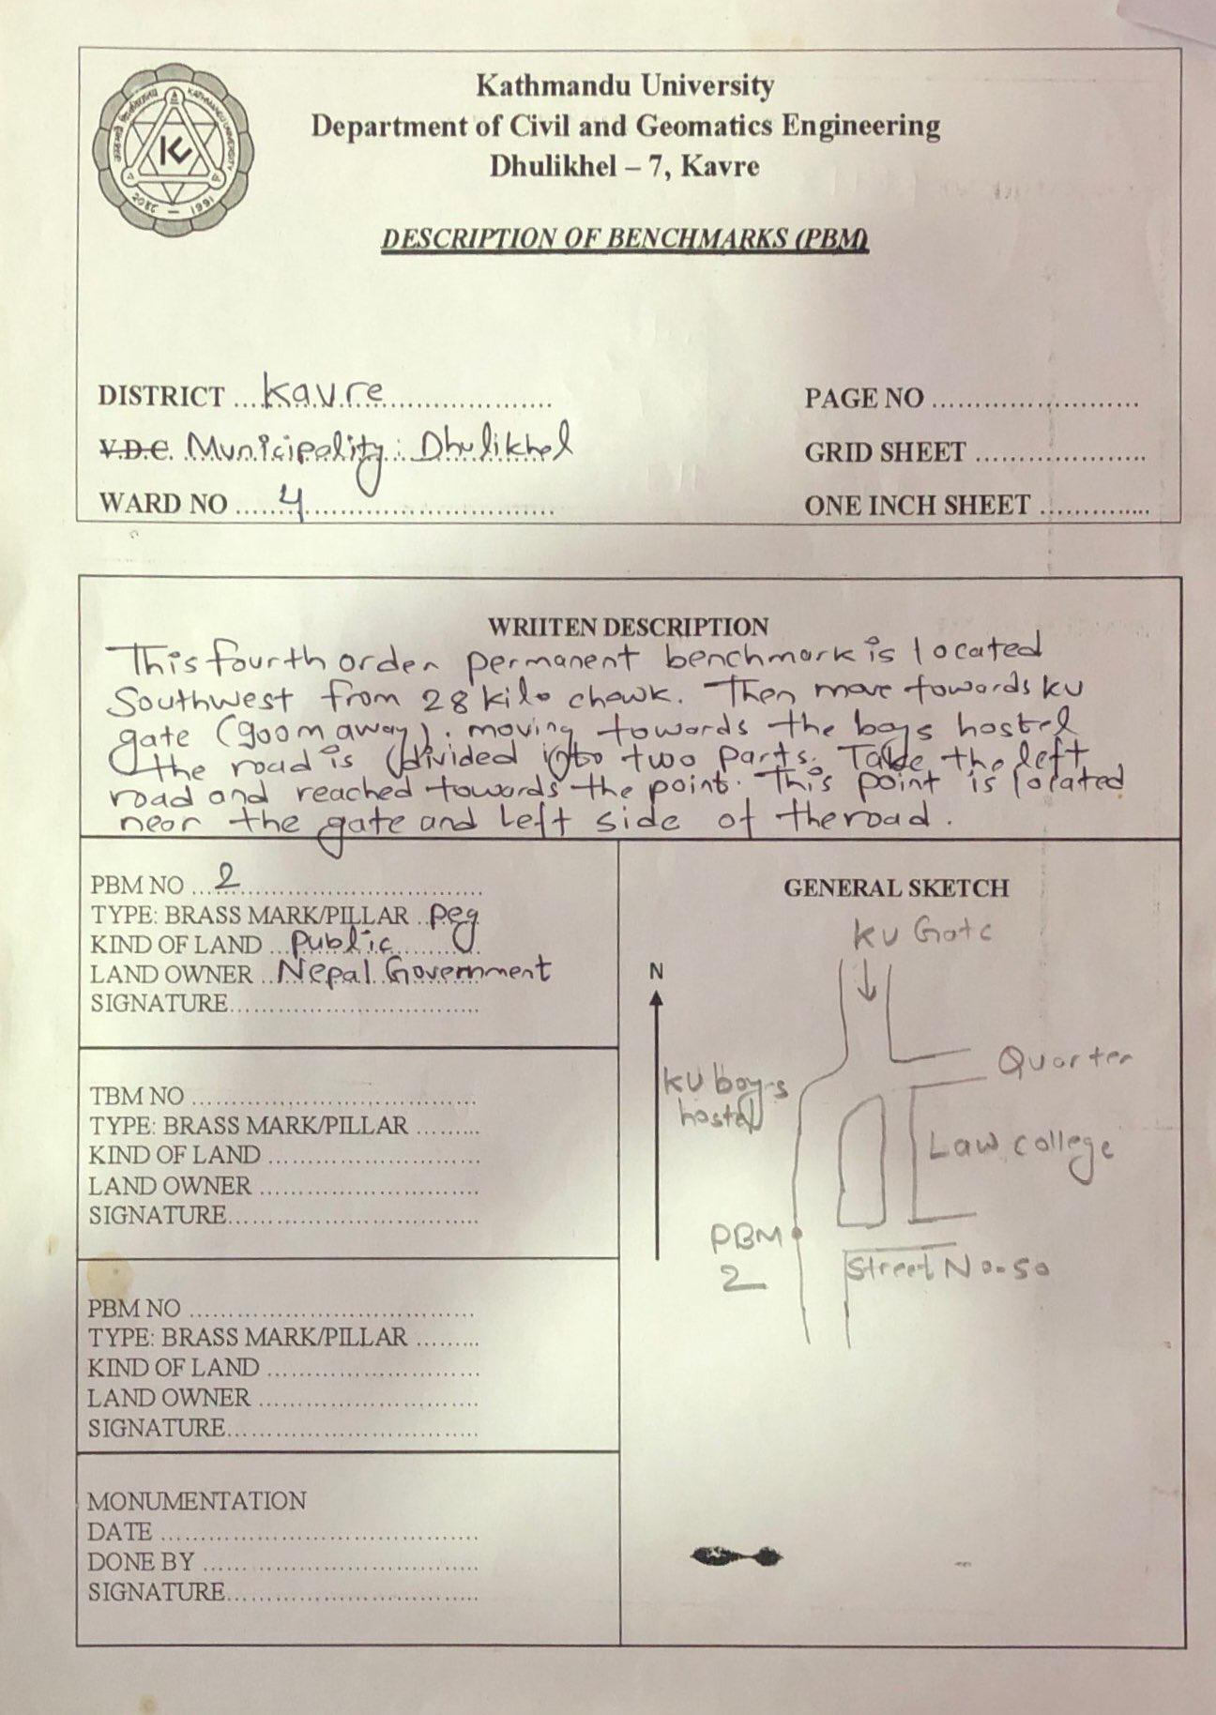
Annex- V : D card of Levelling satation

TRAVERSE

Contents
List of table ii
List of figures iii
List of Abbreviations iv
      - Introduction ...1
        - Background 1
        - Objective of the traverse 1
        - Scope of the project 2
        - Technical terms used in traverse 2
      - Methodology 4
        - Instrument Used 4
        - Area of the project 5
        - Specifications 5
        - Methodology 6
          - Reconnaissance 6
          - Monumentation 6
          - Angular Measurement 7
          - Linear measurement 7
          - Field Computation 7
          - Office computation 8
          - Accuracy assessment 8
        - Sources of error 9
      - Results and Discussion 10
      - Conclusion 11
      - References 12
Annex 13

List of tables
Table 1: Comparison between Link and Loop Traverse 2
Table 2: Specifications 5
Table 3: Observed Measurements 10
Table 4: Coordinates and Elevation 10

List of figures
Figure 1: principle of Traverse 1
Figure 2: Open Traverse 2
Figure 4: Study Area 5
Figure 5: Methodological Diagram 6

List of Abbreviations

CP | Control Point
D-Card | Description Card
E | Easting
EDM | Electronic Distance Measurement
GPS | Global Positioning System
KU | Kathmandu University
LC | Least Count
M | Meter
N | Northing
RO | Reference Object

  - Background

Introduction

Geomatics Engineering, an emerging field of engineering, primarily focuses on acquiring spatial data and establishing the necessary control networks. Control surveys are crucial tools and essential skills for surveyors, as they provide the horizontal and vertical control points required before starting any survey work. These points are established through methods such as traversing, triangulation, and trilateration for horizontal control, and leveling for vertical control.
A traverse consists of a series of connected lines whose lengths and directions are measured in the field. Surveying these field measurements is known as traversing (Roy, 1999). In traversing, a framework is formed by several connected survey lines, with the directions and lengths of these lines measured using an angle (or direction) measuring instrument and a tape (or chain) (Punmia & Jain, 2005).
In our project, we measured angles with a theodolite and used an EDM for distance measurements.
The principle of traversing involves the resolution of a vector into its components: a vector with a specific length and direction is broken down into two parts. One component runs along the reference direction (meridian), while the other is perpendicular to the reference direction (meridian). These components represent the displacement of the survey line along the meridian and perpendicular to it, commonly referred to as the latitude and departure of the line.
∆𝐸= latitude and ∆𝑁= Departure
N

ɵ

Lsinɵ

L cosɵ
E

Objective of the traverse

The prime objective of the traverse was to establish the horizontal control point on the specified area. The other sub-objectives of traverse were as follows:
- To perform angular and linear measurements.
- To establish control points to support tacheometry.
- To gain understanding of traverse computation.
- To visualize the Easting and Northing coordinates of points graphically.

Scope of the project
We have established 7 control points on the project area by the method of theodolite traversing. We completed a field survey in 2 week and Office computation in 4 days. The result shows that the stations have been established with accuracy required for fourth order.

Technical terms used in traverse
Open traverse: An open traverse starts from either starts from known or unknown station and ends to another unknown or known station. An open traverse cannot be properly adjusted and it is not mathematically closed.
Closed traverse: A closed traverse begins at a specified traverse station and ends either at the starting station or at another known station within the survey network.

Table 1: Comparison between Link and Loop Traverse

S. N  . | Particular | Loop Traverse | Link Traverse
1. | Description | The network is formed of a number of stations serially connected to form a  Polygon. | The network is formed of a number of stations serially connected to form  a line segment.
2. | Check on angular  measurement | Angular measurement are made are checked with a sum of angles of  Polygon. i.e. (2n±4)*90 degree. | The angular misclosure are checked by comparing calculated and  Observed bearing of the final line.
3. | Suitability | It is suitable for establishing control point in square, rectangular area. | It is suitable for establishing control  points in narrow linear structure such as transmission line etc.
4. | Type of  closure | It is geometrically and mathematically closed | It is mathematically closed.
5. | Adjustment of angular  Measurement | The angular observations are adjusted by applying equal correction to all  angles. | The angular observations are adjusted by applying cumulative  Correction to that line.
6. | Sketch | Fig. | Fig.

Traverse leg: The straight line joining two consecutive survey stations is known as Traverse leg. In Fig. (a) The distance of AB is known as traverse leg.
Bearing: The bearing of a line is the horizontal angle which it makes with a reference line (meridian).
Azimuth: The angle measured clockwise or anticlockwise from north end of any reference meridian is called Azimuth. It is always less than 180˚.
Astronomical observation: In any precise survey, the angular measurements are checked by observing star or sun after certain no. of stations. The process of observing star or sun for determination of azimuth is termed astronomical observation.
Latitude: The projection of any line on meridian is called its Latitude.

Departure: The projection of any line perpendicular to the meridian is called Departure.

Closing error: The amount by which a closed traverse fails to satisfy the requirements of a true mathematical figure, as the length of line joining the true and computed position of the same point is called Closing Error.
Traverse adjustment: There are various methods of adjusting the traverse. The following methods are commonly used for ordinary traverse, having accuracy up to 1 in 10,000.
- Graphical method: For rough survey, such as a compass traverse, the Bowditch rule may be applied graphically without doing theoretical calculations. Thus, according to the graphical method, it is not necessary to calculate latitude and departures etc. However, before plotting the traverse directly from the field notes, the angles or bearings may be adjusted to satisfy the geometric conditions of the traverse.
- Bowditch method: Bowditch's rule is generally used for adjusting a traverse in which the angles and distance are measured with the same precision. The total error in latitude and in the departure is distributed in proportion to the lengths of the sides.
In Bowditch Rule,

Correction to Latitude (or departure) of any sides

= 𝑇𝑜𝑡𝑎𝑙 𝑒𝑟𝑟𝑜𝑟 𝑖𝑛 𝑙𝑎𝑡𝑖𝑡𝑢𝑑𝑒 (𝐷𝑒𝑝𝑎𝑟𝑡𝑢𝑟𝑒𝑠)* ^{𝐿𝑒𝑛𝑔𝑡ℎ} ^{𝑜𝑓} ^{𝑡ℎ𝑎𝑡} ^{𝑙𝑖𝑛𝑒}
𝑃𝑒𝑟𝑖𝑚𝑒𝑡𝑒𝑟 𝑜𝑓 𝑡𝑟𝑎𝑣𝑒𝑟𝑠𝑒

- Transit rule: The transit rule is used to balance a traverse in which the angular measurements are more precise than linear measurements.

In transit rule,

Correction to latitude (or latitude) of any side

=𝑇𝑜𝑡𝑎𝑙 𝑒𝑟𝑟𝑜𝑟 𝑖𝑛 𝑙𝑎𝑡𝑖𝑡𝑢𝑑𝑒 (𝑑𝑒𝑝𝑎𝑟𝑡𝑢𝑟𝑒𝑠) ∗ 𝐿𝑎𝑡𝑖𝑡𝑢𝑑𝑒(𝑑𝑒𝑝𝑎𝑟𝑡𝑢𝑟𝑒) 𝑜𝑓 𝑡ℎ𝑎𝑡 𝑙𝑖𝑛𝑒
𝐴𝑟𝑖𝑡ℎ𝑚𝑒𝑡𝑖𝑐 𝑠𝑢𝑚 𝑜𝑓 𝑙𝑎𝑡𝑖𝑡𝑢𝑑𝑒(𝑑𝑒𝑝𝑎𝑟𝑡𝑢𝑟𝑒𝑠)

- Axis Rule: In the axis method, the corrections are applied only to lengths. The method is used to balance a traverse in which the angles are measured very precisely whereas the distances are not measured precisely.
Linear accuracy: The ration between closing error and total perimeter of the traverse area is called linear accuracy.
Angular accuracy: It indicates the equivalent least count corresponding to the linear accuracy of traverse.
Least count of theodolite: Least count of theodolite is the minimum reading that can be read by theodolite.
EDM: It is the distance measuring instrument whose accuracy is parts per million. The full form of EDM is Electro-Magnetic Distance Measurement.
Traverse Chart: The sketch of the area showing location of traverse stations and general layout of features in the study area is known as traverse table.

  - Instrument Used

Methodology

The instrument used in traverse survey is as follows:

  - Theodolite
  - Ranging Rod
  - Measuring Tape
  - Tripod Stand
  - Ranging Holder
  - Total Station

Area of the project
The area of the project was held in Dhulikhel municipality of Kavre district. The study area of our project is shown below.
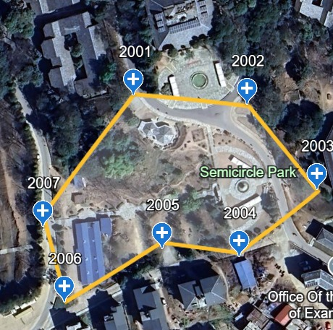

Figure 3: Study Area

Specifications
The specification used for this practical are:

Table 2: Specifications
Particulars | Specification
Order of Work | Fourth order
Purpose: | To establish control point for cadastral and engineering  surveying
Units Of measurement: | Linear measurement: meters  Angular measurement: Degree
Instrument and Method | Linear measurement: EDM  Angular measurement: Zipp 02
Linear Measurement direction | Two-way, double measurement
No. of sets for angular  Measurement | Three sets
Value for RO for different set | 0° , 60° , 120°
Permissible collimation Error | 1'10”
Permissible index error | 2'42"
Set to set tolerance | 19.40 Sec
Required accuracy in horizontal angle | 25 √N sec , N refers to numbers of Station
Required Linear accuracy | 1:10000
Adjustment Methods | Linear misclosure: Bowditch rule  Angular misclosure: Equal shift
Coordinate system | Easting, Northing on National grid

Methodology
Following figure clarifies the methodology of traversing.

Reconnaissance
First of all, we decided to visit the field at KU premises. No any maps were collected because the traverse area was small. Thus, checking the Intervisibility, we completed the field visit.
While choosing the control point:

      - Traverse legs were balanced.
      - Stable ground was chosen for the station in order to make the instrument set up easement.

Monumentation
Selected control points were numbered using fourth order numbering. Since it is the fourth order traverse, we monumented the control point using the wooden pegs. In total 7 control points were monumented. After Monumentation, we should have prepared the D-Card but instead of D-Card, we roughly sketched the traverse area with the control point in it.
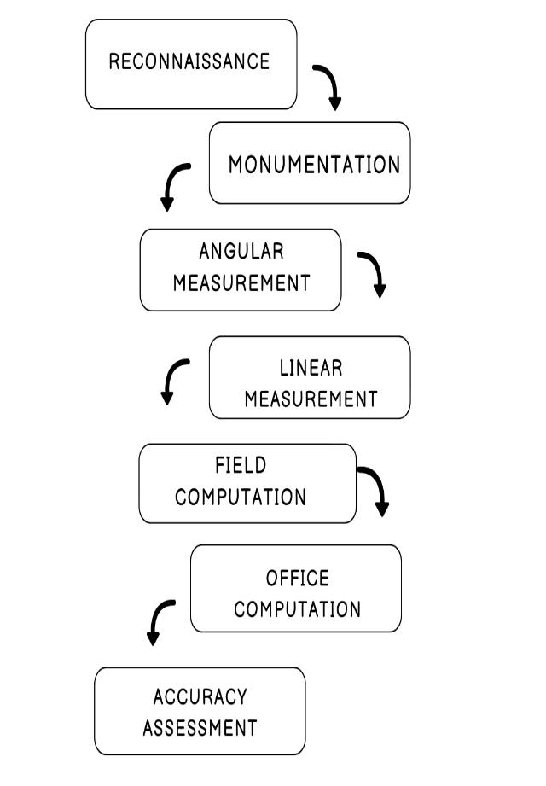

Figure 4: Methodological Diagram

Angular Measurement
Before observation of an angles in each control point’s temporary adjustment of instrument was done.
After adjusting following sequence was maintained all over the stations:

      - First of all, angle of theodolite was set to zero on face left condition at backward station.
      - After then, by swinging the telescope the angle was taken on face left condition then simultaneously on face right condition at forward station.
      - After swinging the theodolite, it was again signaled in backward station and the angle formed was recorded in field book.
      - This process was done up to three set by setting the angles 0˚10’0”, 60˚10’0”, 120˚10’0” respectively.

Same process was repeated until the loop was closed.

Three set measurement were taken in a station in order to minimize the graduation error of the instrument.
Horizontal angle was measured on both faces in order to minimize the collimation error in the instrument.
Observed Angles are attached with this report in Annex portion.

Linear measurement
For measuring the distance, Total station was used. From one station two distance measurement were taken one at backward station and another forward station. The distance was measured by sitting in the alternate angles. And the same operation is done in all the survey stations.

Field Computation
The following process was done in the field surveying:

- At first the horizontal angle on FL and FR was get compared if the angles on FL and FR were differ by 180˚ and RO was assumed to 0 set.
- Secondly the obtained angle was subtracted from the average of angles taken on next station.
- Same process was repeated for 2nd and 3rd sets. And After that
  - The angle was taken from face left reading of 1st set and mean of minute and seconds of three sets was done to calculate the horizontal angle between the stations.
  - For zenithal angle, the sum of both faces was done and necessary correction was done to make the sum 360˚.

- Same process was applied in 2nd and 3rd set by setting the angles at 60˚10’0” and 120˚10’0” respectively.

- Then the actual preferred refined angle we got by averaging these 3 set horizontal reading.

Office computation
First of all field book was serially arranged as a loop and then the recorded angles and distance were again recorded in computational sheet.
Horizontal and Zenithal angle were measured in a station, they were recorded in their respective column. The distance measured was also recorded in its column.
Theoretical sum of external angle should be (2n-4)*right angle. If the external angle did not satisfy this condition equal error was distributed in each External angle.
Bearing calculation: Initial bearing of line was provided.

All other bearing of lines were calculated by using following formula,

= Bearing of previous line ±180 -(Interior angle+ correction of angle) of that line.

For computation of latitude and longitude following formula was used:

∆𝐸 = 𝐿 sinB , ∆𝑁 = 𝐿 cos𝐵

Where, ∆𝐸= Latitude ∆𝑁= Departure

𝐿= length of that line

𝐵= Bearing of that line

Error on latitude and departure were adjusted by Bowditch method.

Bowditch method was applied because angle was measured up to second and distance also was measured up to mm which means both angular and linear measurements were of same precision.
Coordinate of the lines were computed by following formula:
=Coordinate (Easting and Northing) of previous line + ∆E (∆N) + correction on ∆E (∆N). Finally obtained coordinate was equal to that of known station's coordinate.
The field computation sheet was attached with this report in Annex.

Accuracy assessment
The accuracy for the any traverse can be calculated by following factors.

- Closing Error (e)= √((ΔE)² +(ΔN)²)
= √((0.010)² +(0.034)²)
= 0.035244672
It means the calculated point for the initial point is 8 cm far from the initial point in the loop.
- Angular Accuracy = = 25 √𝑁𝑠𝑒𝑐

- Linear accuracy = 1 : ^{𝑃}
𝑒

Where perimeter of the loop (p) = 364.913 m. & closing error (e) = 0.034
= 1: 10353.70667

The computation of the Accuracy is in Annex.

Sources of error
There are three sources of error in Survey:

- Personal error
- Instrumental error
- Natural error
Personal error: The error introduced by personally is called personal error. They were

- Error due to inaccurate centering
- Error due to inaccurate leveling
- Error due to inaccurate reading
- Error due to inaccurate sighting
Instrumental error : The error introduced by instruments is called instrumental error. They were
- Error due to imperfect adjustment of the level tube
- Error due to line of collimation
- Error due to imperfect graduation of the horizontal scale

Natural error : The error introduced by natural causes is called natural error. They were:

- Error due to Wind
- Error due to Refraction Effect
- Error due to temperature

Results and Discussion
Following outputs were obtained.

Table 3: Observed Measurements

S.N. | Stations | Observed Angle | Distances (in m.) | Zenithal Angle
1 | 2001 | 248˚21’35” | 79.733 | 90˚18’24”
2 | 2002 | 243˚45’34” | 45.332 | 95˚23’47”
3 | 2003 | 252˚18’25” | 41.034 | 95˚43’03”
4 | 2004 | 224˚59’30” | 36.326 | 102˚40’31”
5 | 2005 | 144˚29’39” | 54.776 | 99˚30’04”
6 | 2006 | 280˚19’09” | 36.606 | 93˚05’38”
7 | 2007 | 225˚47’24” | 71.106 | 71˚52’44”

Table 4: Coordinates and Elevation

Station | Co-ordinates |  | Elevations (In m.)
Station | Easting (ΔE) (in m.) | Northing (ΔN)  (In m.) | Elevations (In m.)
2001 | 355751.956 | 3055807.429 | 1519.236
2002 | 355826.953 | 3055780.357 | 1519.721
2003 | 355832.005 | 3055735.303 | 1516.161
2004 | 355794.545 | 3055718.547 | 1513.134
2005 | 355760.607 | 3055731.499 | 1505.676
2006 | 355707.602 | 3055717.669 | 1497.001
2007 | 355704.854 | 3055754.168 | 1495.684
2001 | 355751.955 | 3055807.429 | 1519.236

Hence, 7 Control points were established with the help of theodolite and ranging rod.

Following table shows the output of accuracy in traverse.

Table 5: Accuracy Obtained

Error | Value
Closing error | 0.035244672
Linear accuracy | 1: 10353.70667 ≈ 1: 10354
Angular accuracy | 25√N sec

Conclusion
Therefore, through the traverse method, we established control points. During our survey, we gained practical experience in angular and linear measurements using theodolite and Total Station. We acquired theoretical knowledge in office computations related to traverse. This experience enhanced our confidence in establishing control points via traverse methods when given a survey area and the necessary instruments.

References

Punmia, B., & Jain, A. K. (2005). Surveying, Vol.1. I, 161.

ANNEX

Here are some glimpse of photo

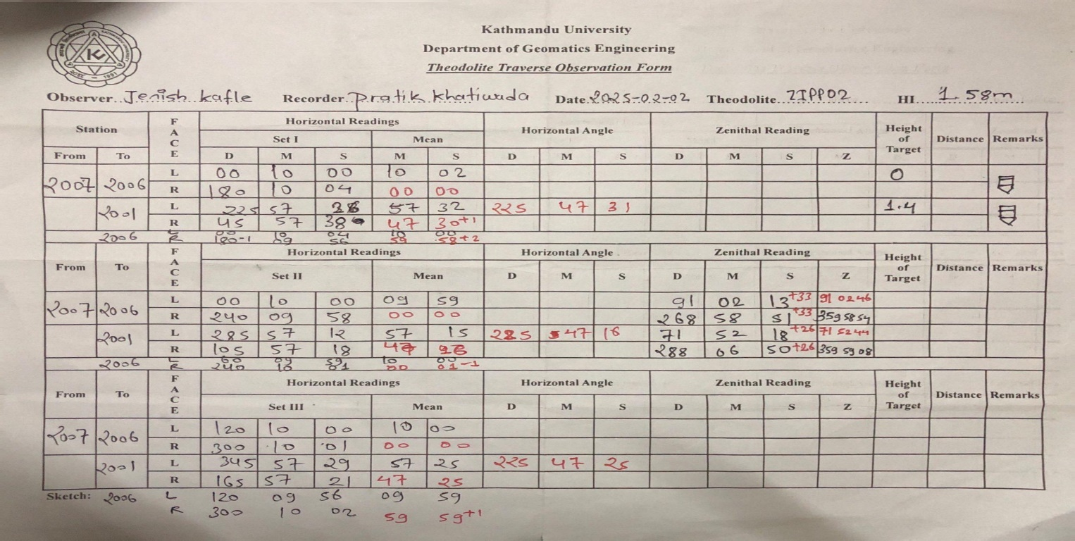

Annex- I : Field book of Traverse

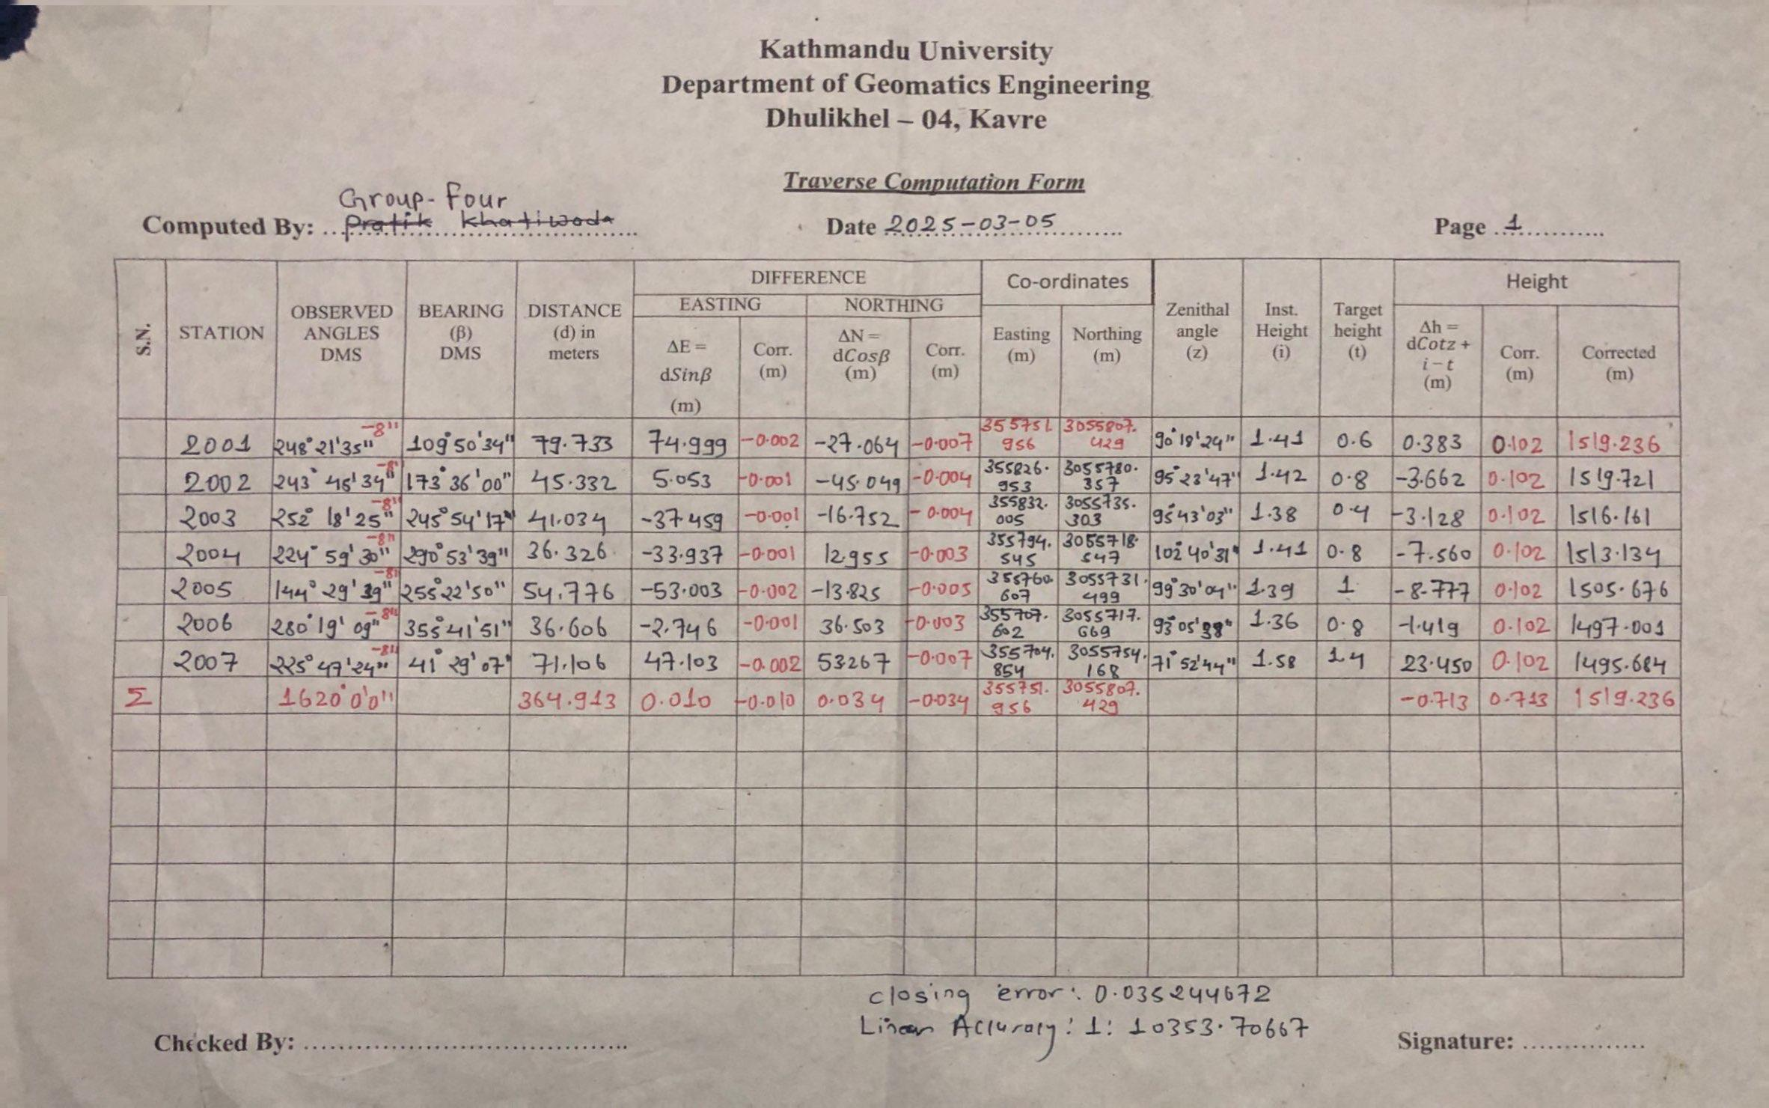

Annex- II : Traverse Computation Form

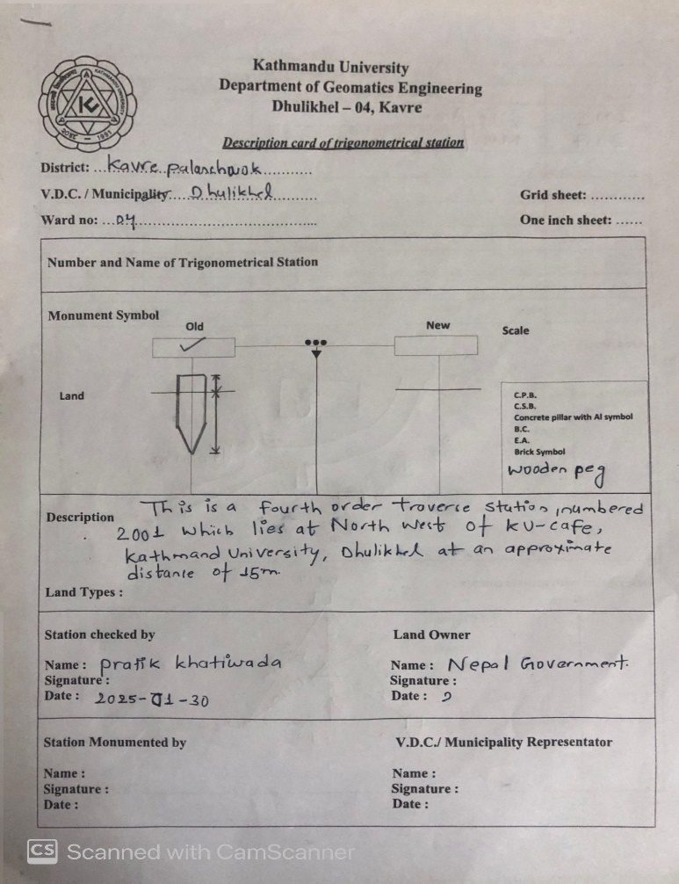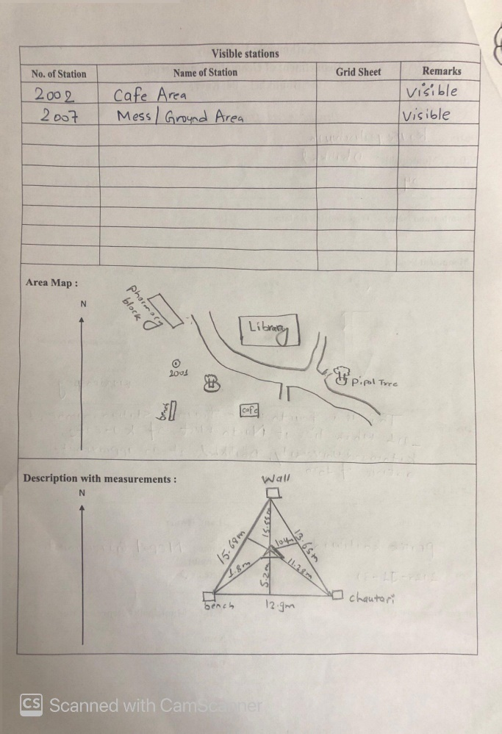

Annex- III: D-Card of Traverse Station

TACHEOMETRY

Contents
List of Table ii
List of Figure iii
List of Abbreviation iv
- Introduction 1
  - Background 1
  - Objective of tacheometry 1
  - Scope of the Project 2
  - Terms used in tachometry 2
- Methodology 3
  - Instrument used 3
  - Area of the project 3
  - Specification 4
  - Methodology 4
    - Establishment of control point 4
    - Detailing 5
    - Office Procedure 5
2.5 Layout 6
  - Source of Error 6
    - Personal Error 6
    - Instrumental error 6
2.6.3 Natural error 6
- Output 7
- Conclusion 7
- Reference 8
Annex 9

List of Table
Table 1: Specification 4

List of Figure
Figure 1: Principle of Tacheometry 1
Figure 2: Study Area 3
Figure 3: Methodological Diagram 4

List of Abbreviation

CP | Control Point
D-Card | Description Card
E | Easting
EDM | Electronic Distance Measurement
GPS | Global Positioning System
KU | Kathmandu University
LC | Least Count
N | Northing
RO | Reference Object

  - Background

Introduction

Tacheometry or tacheometric surveying is a type of angular surveying that uses optical techniques to find horizontal and vertical distances, instead of the slow conventional methods involving chains or tapes (Punmia & Jain, 2005). It does not need corrections usually needed in tape or chain measurements, e.g., slope and tension. Although tacheometric measurements are not quite so accurate as chaining along level ground, they are preferable on undulating ground.
It is particularly useful for such work as the compilation of topographical maps, initial survey for railways, roads, canals, and reservoirs, mapping of steep country and watercourses. In accurate surveys, tacheometry can also be employed as a quick check instrument for tape or chain measured lengths (Duggal, 2013). The measurements are recorded using a stadia rod, typically a leveling staff with a finer scale (1 cm), and horizontal and vertical lengths are computed from these measurements.
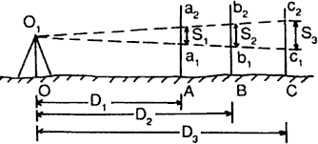
The principle of tacheometry is based on property of isosceles triangles, where the ratio of distance of the base from apex and length
of the base is always constant.

𝐷1
=
𝑆1
𝐷2
=
𝑆2
𝐷3

𝑆3
𝐷4 𝑓
= =
𝑆4 𝑖

- F= focal length of object and
- i= stadia intercept

Objectives of tacheometry

Figure 1: Principle of Tacheometry

The primary objective of tacheometric survey was to prepare topographic map. Other sub-objectives were:
    - To compute the horizontal distance, height difference and reduced level of details from the observation data.
    - To learn the techniques of detailing, contour interpolation and plotting.
    - To gather planimetric and altimetric data on the project site's specifics.

Scope of the Project
For our project focused on tacheometry, we concentrated on gathering detailed information about the project area. The selected areas for tacheometric surveying included the boundaries of KU mess, Staff Quarter, Fountain areas, roads, buildings, and their surroundings. Additionally, we also recorded spot heights in the project area, making it challenging to accurately judge elevations when drawing contour lines.

Terms used in tachometry
Tacheometer: A tacheometer is a theodolite fitted with stadia diaphragms. The distance between the stadia is always fixed but it may be change using screw.
Transiting: The process of rotating the telescope of theodolite about horizontal axis is called transiting.
Leveling: The process of making the vertical axis of theodolite truly vertical is called leveling.

Swinging: The process of rotating the theodolite about vertical axis is called a swinging.

Anallectic Lens: It is a convex lens provided in a telescope between the object lens and eye piece to eliminate the additive constant from the tacheometric equation. Its additive constant is zero.
Stadia Rod: It is also known as vertical stave. It is a rod of 3-5 m. long, graduated in decimals of a meter.
Tacheometer Station: It is a station, the details are taken while observing.

Line of collimation: Line joining the intersection of the cross hair to the optical center is called line of collimation.
Contouring: Contouring refers to the method of locating contour or collecting necessary data (Spot Heights) require for determining contour of the ground.
Contour Interpolation: The method of determining the positions of contour passing between two points from the information of their height difference and horizontal distance between them.
Contour Equivalent: The horizontal distance between contours is called Contour Equivalent.

  - Instrument used

Methodology

Following instruments were used during Tacheometer surveying.

A Tacheometer with tripod | 1 set
Staffs of 5 m | 2 set
Ranging rods | 2 set
Measuring Tape | 1 set

Area of the project
The study area of the project was Dhulikhel municipality of Kavre district. Figure below shows the project area.

Figure 2: Study Area

Specification
The adopted specifications during tacheometry were:

Table 1: Specification

Particulars | Specification
Theodolite | Zipp -02
Staff | 5 m with least count of 5 mm
Contour interval | 1 m
Index Contour | 5 m
Scale | 1:500
Theodolite to staff Distance | Less than 60m

Methodology
Following procedure was performed:
Field Works
Office Works
Procedure of Tacheometry Survey
Detailing
Contour Interpolation
Establishment of control points
Plotting of detail
Layout

Figure 3: Methodological Diagram

Establishment of control point
Control points established from traverse method was used for the tacheometric surveying which were of fourth order.

Detailing
We performed detailing in following ways:
      - First of all, a theodolite was set up over a station. Temporary adjustment was done. i.e. centering, levelling.
      - Height of instrument & RL of the station was recorded in field book and field sketch for that station was prepared by sketch man.
      - After then, RO was sighted by making horizontal angle 0° for orientation.
      - Staffs were placed in required position for detailing.
      - Five measurements were taken to locate those details i.e. Top (T), Middle (M), Bottom (B), Horizontal angle and Zenithal angle and they were recorded in field book.
      - Point number of details was assigned and Remarks was also given to those details in Field book. Similarly, same number was written sketch too.
      - Then, Horizontal and vertical distance were computed as following formula Horizontal Distance = KSsin²Z
Vertical distance =KSsinZ.cosZ
Where, K= Multiplying constant whose value was 100 for our theodolite S = Staff intercept i.e. (T-B),
Z = Zenithal Angle
And they were recorded in field book.
      - Similar processes were performed in each stations.

Office Procedure
After the completion of the Field work, office work was done. Following procedure was done in office procedure.

Plotting of details
        - First of all, a permanent tracing paper was taken and Grid lines were drawn and the control points were plotted accurately on the sheet.
        - To plot the data, Compass was exactly placed below the control point in a sheet and two stations were joined by a line where the Ro was set.
        - The Zero of the compass was placed on that line where RO is set. And all the details were plotted on the scale (1:500) using the horizontal angle and the computed horizontal distance.
        - After the completion of the plotting of details from one control point, then it was shifted to another control point. And similar process was performed for plotting the details in every control points.
        - Features were created after completion of plotting details
        - Then a new tracing paper was attached to the permanent tracing paper and the planimetric as well as altimetric details were traced for contour interpolation.

Contour interpolation
Contour interpolation in tacheometry was done by eye estimation methods; This method was performed to locate other contour lines such as intermediate contour point and supplementary contours. Intermediate contours were plotted in 1 m contour interval. Lines were drawn with the help of guide points plotted previously. Hence all the required contours were made in temporary tracing paper.
Finally, the contour lines were traced to the Permanent tracing paper from temporary tracing paper.

2.5 Layout
After the contours were traced , Legends, scale bar, title, north arrow, bibliographic information were written on the map as per specification. Grid values were also written on the side of the maps.
Index contour was made thicker but other contours were thinner which helps in visualization. These bolded and labeled contour lines are usually referred to as the index contour lines. The remaining contours are called intermediate contours.

Source of Error
The following were the sources of error in tacheometry survey:

Personal Error
The following were the personal error

      - Centering error
      - Wrong sighting
      - Mis-reading and mis-recording
      - Miscalculation
      - Use of wrong tangent screw

Instrumental error
The following were the instrumental errors:

      - Index error
      - Defective bubble tube
      - Collimation error
      - Graduation error in Horizontal Circle
      - Defective illuminating mirror

Natural error
The followings are the Natural source of the error:

      - Error due to simmering
      - Error due to Refraction

3 Output

A topographical map of the Kathmandu University premises was created, featuring contour lines at 1-meter intervals derived through interpolation using spot heights. Planimetric features were selected from a sketch of specific control sites, including surrounding elements like buildings, roads, electric poles, and fences. The collected data was utilized to ascertain horizontal distances, elevation differences, and reduced levels of various features.

4 Conclusion

Data was collected by observing the staff with the theodolite, and this data was analyzed to calculate horizontal distances, height differences, and reduced levels. Both planimetric and altimetric data were gathered, and techniques for detailing, contour interpolation, and plotting were learned. Ultimately, a topographic map of the survey area was created. Throughout the fieldwork, we gained extensive knowledge about tacheometric surveying. In the process, around 1 tacheometric details were recorded. The equipment used in tacheometric surveys is well understood. Given a survey area and the necessary instruments, we are now confident in our ability to create a topographic map using tacheometric survey methods.

5 Reference

Duggal, S.K. 2013. 1 SURVEYING. India Binding House.
Punmia, B.C, and Ashok Kumar Jain. 2005. “Surveying, Vol.1.” I: 411.

Annex

Here are some glimpse of photo

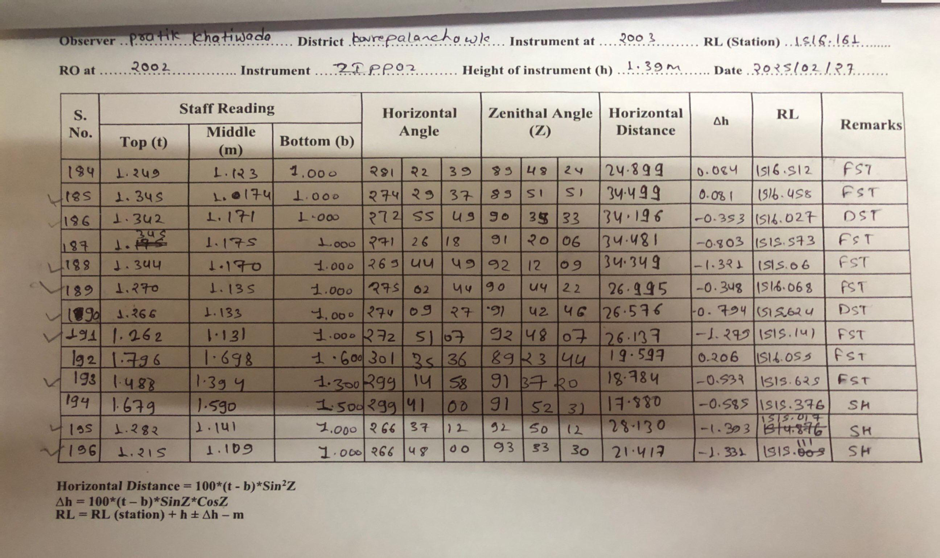
Annex – I: Field Book of Tacheometry surveying

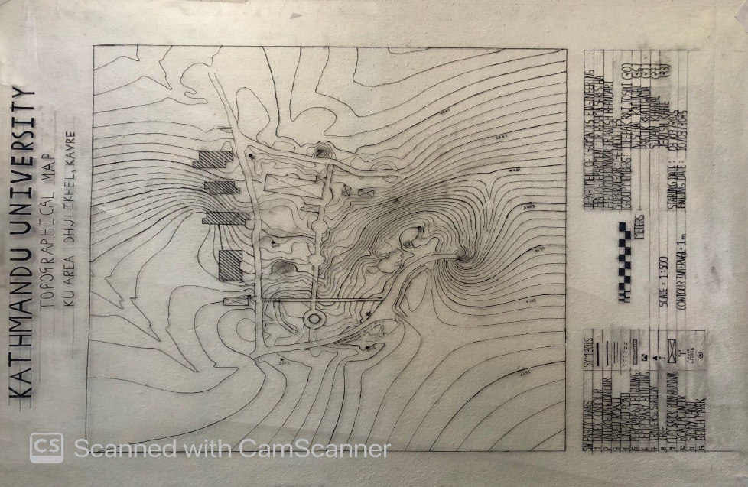

Annex – II: Topographical Map

